EXPERIMENT 1
INTRODUCTION TO COMPUTER NETWORKS AND THE CISCO PACKET TRACER (CPT)

EXPERIMENT 1(a): CPT Platform Overview
1. Aim
To understand the interface, tools, icons, and functionalities of Cisco Packet Tracer and learn how to create and manage network topologies
2. Software Used
- Cisco Packet Tracer
3. Introduction
Cisco Packet Tracer is a network simulation tool used to design, configure, and troubleshoot computer networks in a virtual environment. It provides both logical and physical views of a network along with simulation capabilities.
🔷 4. Interface Overview (Main Screen Components)
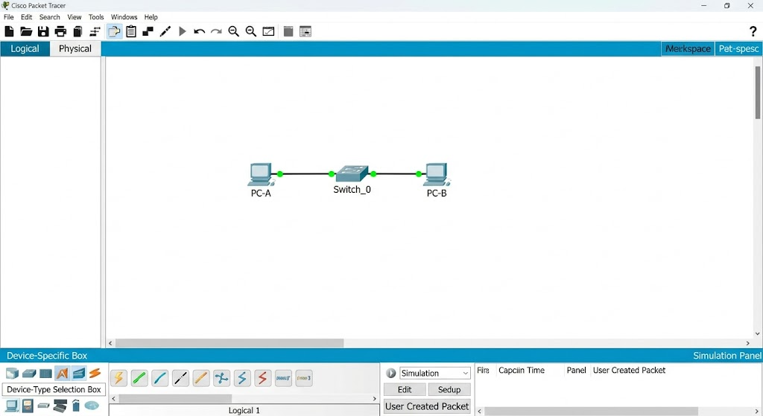
4.1 Menu Bar
Located at the top of the window.
Functions:
- File: New, Open, Save projects
- Edit: Undo, redo
- Options: Preferences/settings
- View: Zoom, grid
- Tools: Activity wizard, extensions
4.2 Tool Bar (Main Toolbar Icons)
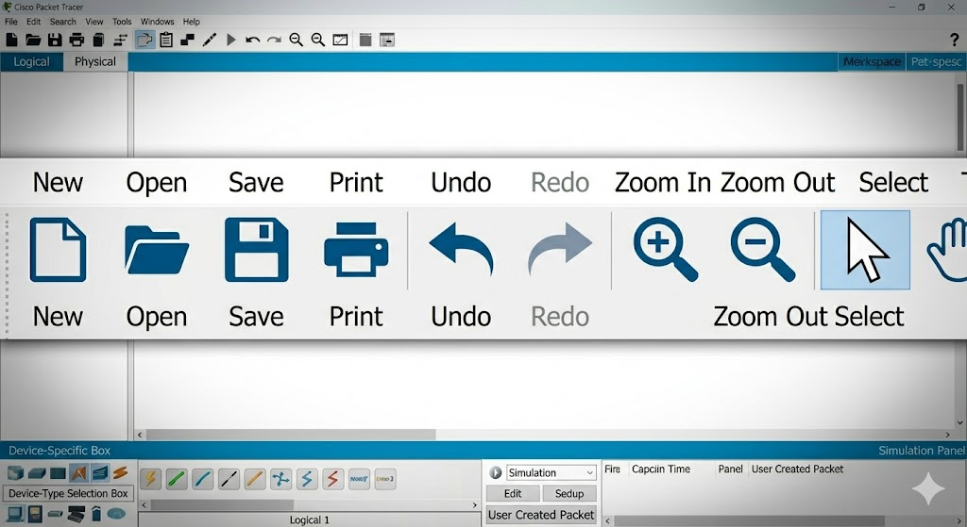

- [📄] New → Create new project

- [📂] Open → Open saved file

- [💾] Save → Save current work

- [🖨️] Print → Print topology

- [↩️ ↪️] Undo/Redo → Reverse actions

- [🔍➕/➖] Zoom → Adjust view

- [🖱️] Select → Move/select devices

- [✋] Move Layout → Move screen

4.3 Workspace Area
Two types:
(a) Logical Workspace
- Used to design network topology
- Add routers, switches, PCs
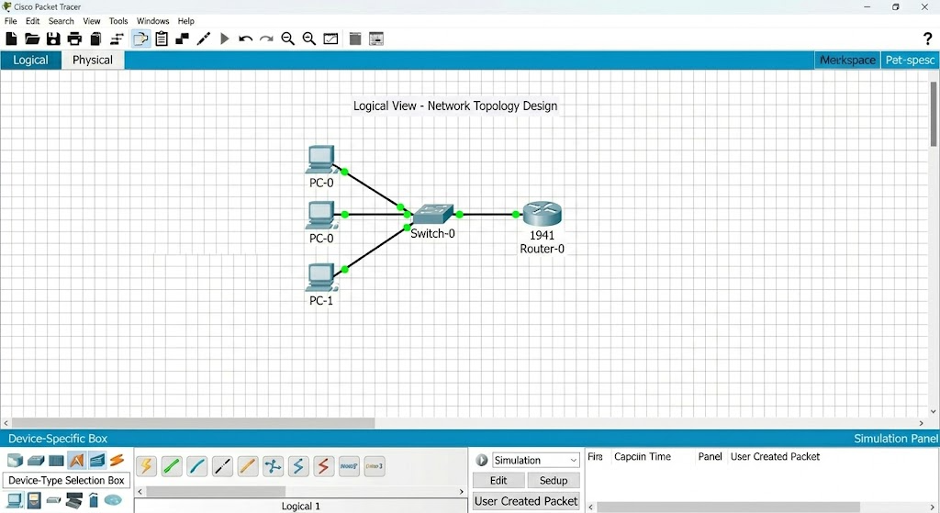

(b) Physical Workspace
- Real-world representation (buildings, rooms)
- Shows physical placement of devices
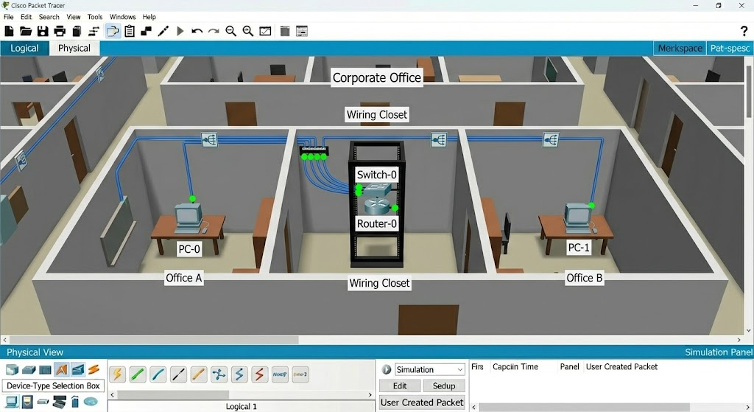

4.4 Device-Type Selection Box
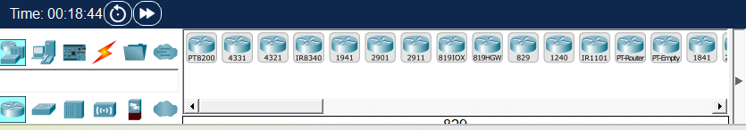
Categories:
- Network Devices
- End Devices
- Components
- Connections

4.5 Device-Specific Selection Box
- Displays devices like:
  - Routers
  - Switches
  - PCs
  - Servers

4.6 Connections Icon (⚡ Important)
Cable Type | Use
Copper Straight Through | PC to Switch
Copper Cross Over | Switch to Switch
Fiber Cable | High-speed connections
Serial Cable | WAN links
Console Cable | Configuration

4.7 Simulation Panel
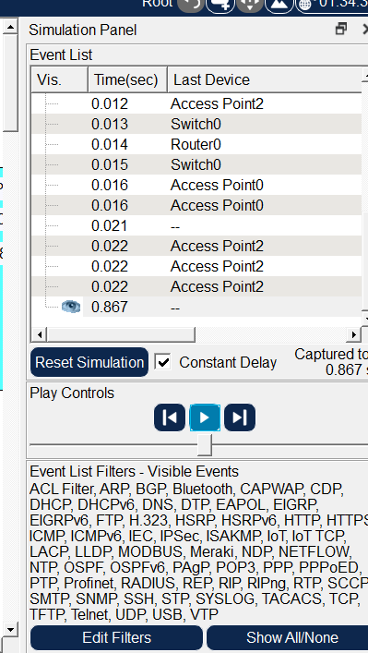
Functions:
- Event List (packet flow)
- Play/Pause simulation
- Capture packets
- Filters (ICMP, TCP, etc.)

🔷 5. Options & Customization
- Change interface colors
- Enable/disable grid
- Configure fonts
- Adjust simulation speed
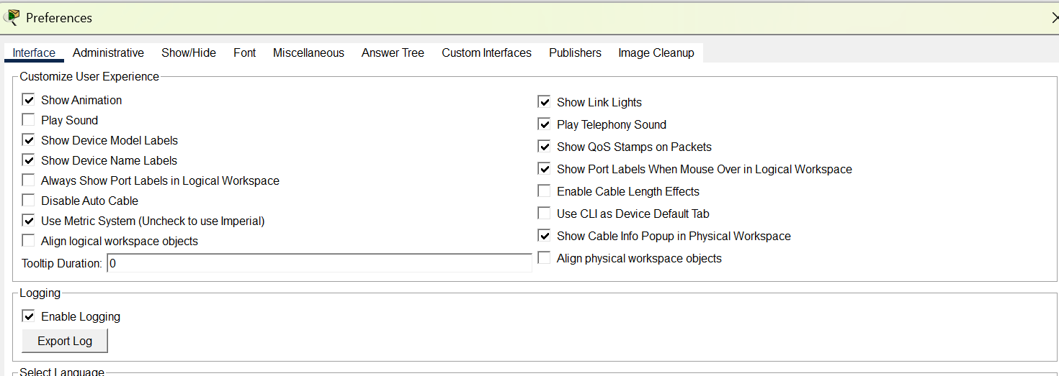

🔷 6. Logical Workspace Operations

6.1 Creating Network Topology
Steps:
- Select device category
- Drag device to workspace
- Connect using cables
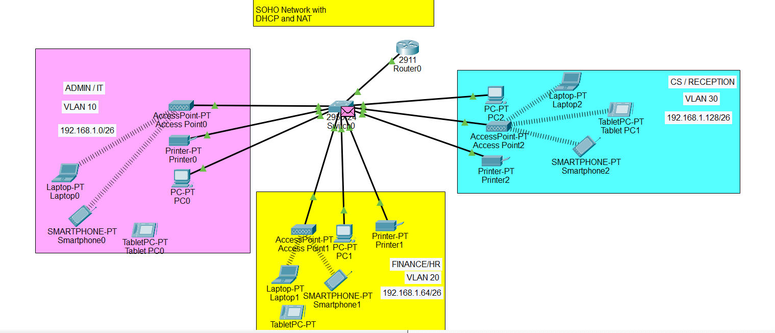

6.2 Custom Device Templates
- Save frequently used devices
- Reuse configurations

6.3 Clustering Network
- Group multiple devices
- Simplifies large networks
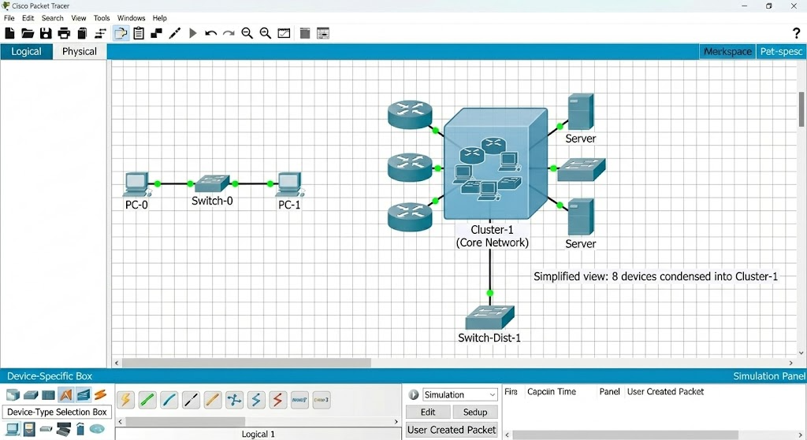

6.4 Annotation Tools
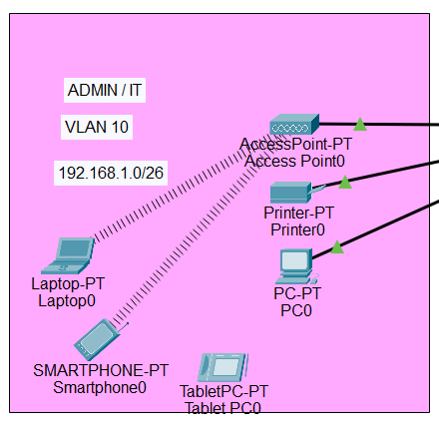
- Add text labels
- Draw shapes
- Highlight connections

🔷 7. Device Configuration Tabs
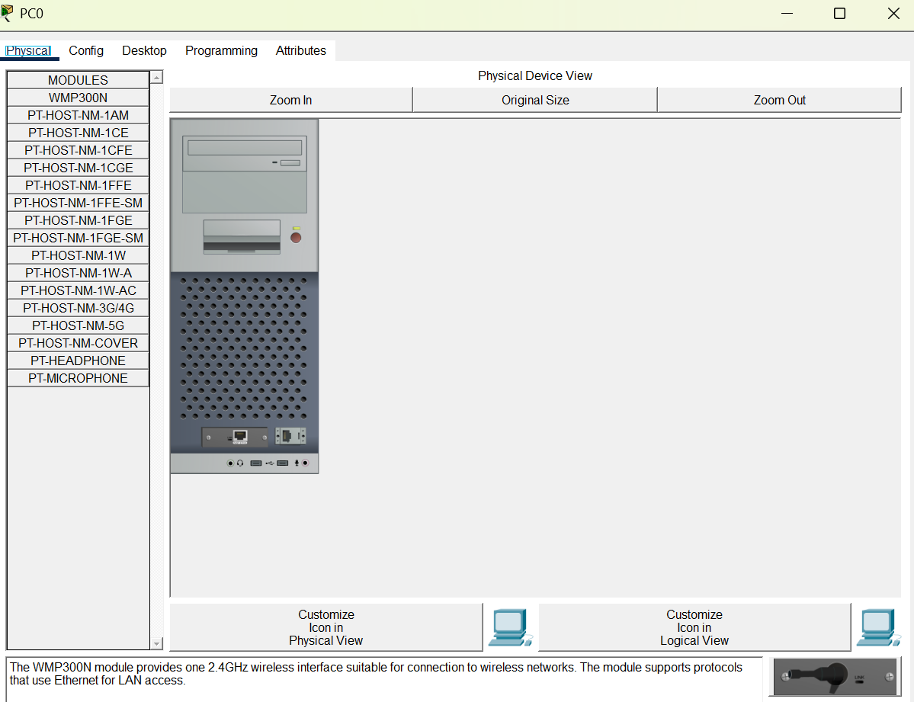

7.1 Config Tab
- GUI-based configuration
- Set IP, routing, interfaces

7.2 Desktop Tab
- Used in PCs
- Tools available:
  - IP Configuration
  - Command Prompt
  - Web Browser

7.3 Services Tab
- Configure services like:
  - DHCP
  - DNS
  - HTTP

7.4 CLI Tab
- Command-line interface
- Used for real Cisco commands
📌 Example:
ip address 192.168.1.1 255.255.255.0

🔷 8. Realtime vs Simulation Mode
Mode | Description
Realtime | Instant network operation
Simulation | Step-by-step packet flow
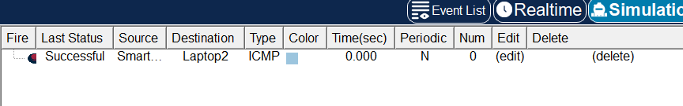

🔷 9. Physical Workspace
- Shows buildings, wiring, racks
- Helps in real-world network design

🔷 10. Important Icons Summary
Icon | Meaning
Router | Network routing
Switch | Connect devices
PC | End device
Server | Provides services
Cloud | Internet/WAN
Wireless Router | Wi-Fi network

🔷 11. Result
Successfully understood the Packet Tracer interface, tools, icons, and basic network creation.

EXPERIMENT 1(b): Peer-to-Peer Network

1. Aim
To design and implement a Peer-to-Peer (P2P) Network using Cisco Packet Tracer and understand direct communication between devices without a central server.

2. Objective
- To understand the concept of Peer-to-Peer networking
- To create a small P2P network
- To configure IP addresses manually
- To test connectivity between devices

3. Theory
A Peer-to-Peer (P2P) Network is a type of network where all devices (nodes) are equal and can act as both client and server.
👉 There is no central server
👉 Each computer shares its own resources
👉 Suitable for small networks (home, labs)
🔹 Key Features:
- Decentralized network
- Easy to set up
- Low cost
- Direct communication between devices

4. Requirements
- 2 PCs (minimum)
- 1 Switch (optional but recommended)
- Copper Straight Through Cable
- Packet Tracer software

5. Network Topology
👉 You will design:
- PC1 ↔ PC2 (direct or via switch)

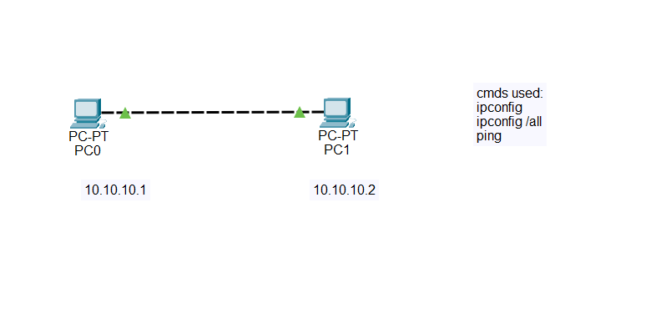

6. IP Addressing Table
Device | IP Address | Subnet Mask
PC1 | 192.168.1.1 | 255.255.255.0
PC2 | 192.168.1.2 | 255.255.255.0

7. Procedure
Step 1: Add Devices
- Open Packet Tracer
- Drag and drop 2 PCs into workspace

Step 2: Connect Devices
- Use Copper Cross-Over cable (direct)
OR
- Use Switch + Straight Cable

Step 3: Configure IP Address
👉 On PC1:
- Desktop → IP Configuration
- IP: 192.168.1.1
- Subnet Mask: 255.255.255.0
👉 On PC2:
- Desktop → IP Configuration
- IP: 192.168.1.2
- Subnet Mask: 255.255.255.0

Step 4: Test Connectivity
- Go to PC1 → Command Prompt
- Type:
ping 192.168.1.2
👉 If reply received → Network is working ✅

8. Result
The Peer-to-Peer network was successfully created and communication between devices was verified using ping command.

9. Advantages
- Easy to set up
- No server required
- Cost-effective
- Direct resource sharing

10. Disadvantages
- Less secure
- Not scalable
- No centralized control

EXPERIMENT 2
VIZUALIZATING THE VARIOUS NETWORK TOPOLOGIES

EXPERIMENT 2(a): Star Topology

1. Aim
To design and implement a Star Topology using Cisco Packet Tracer.

2. Theory
In Star Topology, all devices are connected to a central device (switch/hub). All communication passes through this central node.

3. Network Diagram
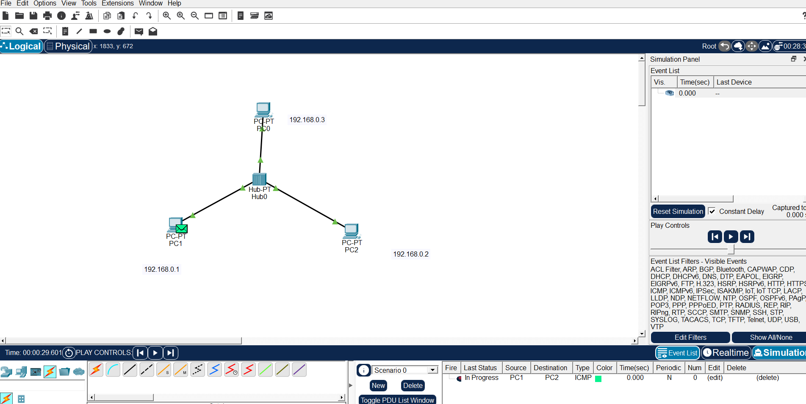

4. Procedure
- Add one switch
- Connect multiple PCs to switch
- Assign IP addresses
- Test connectivity using ping

5. Result
Star topology was successfully created and verified.

(Networking & Devices)
Parameter | Details
Network Type | Campus Area Network (CAN)
Connecting Devices | Switch, PCs, Ethernet cables
Explanation | Star topology is widely used in campus networks where all devices connect through a central switch, making management easy and efficient.

EXPERIMENT 2(b): Ring Topology

1. Aim
To design and implement a Ring Topology using Cisco Packet Tracer.

2. Theory
In Ring Topology, devices are connected in a circular form, and data flows in one direction through each node.

3. Network Diagram
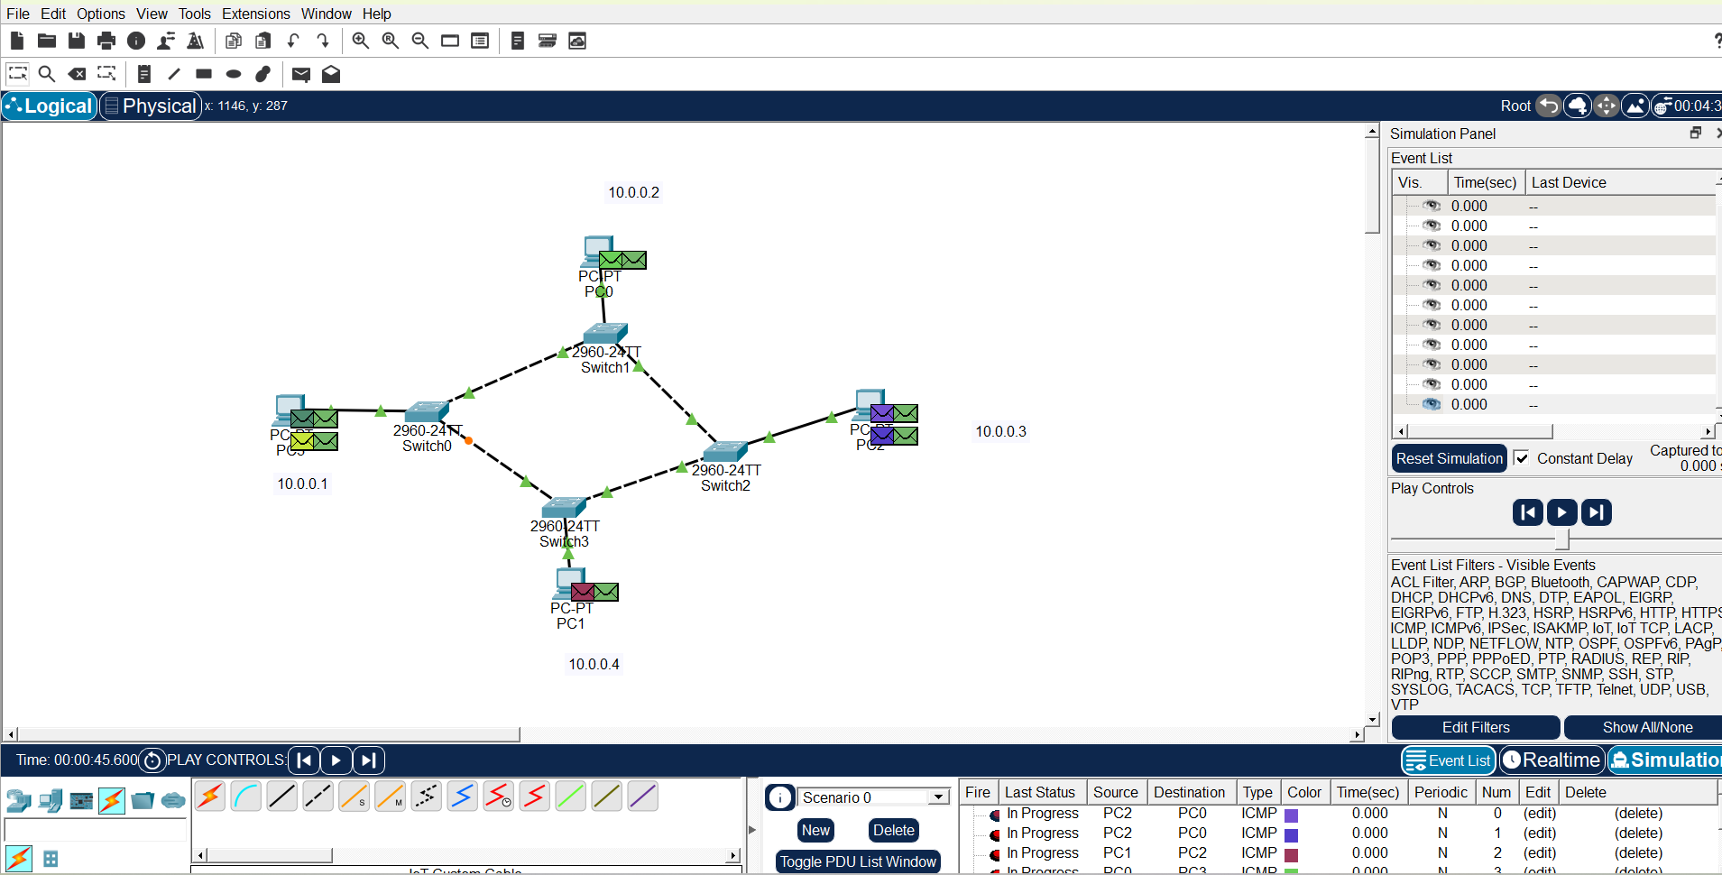

4. Procedure
- Arrange PCs in circular layout
- Connect each PC to the next
- Assign IP addresses
- Test connectivity

5. Result
Ring topology was successfully implemented and tested.

(Networking & Devices)
Parameter | Details
Network Type | Local Area Network (LAN)
Connecting Devices | PCs, Ethernet cables
Explanation | Ring topology is suitable for small LANs where controlled data flow reduces collision and ensures equal access.
EXPERIMENT 2(c): Mesh Topology

1. Aim
To design and implement a Mesh Topology using Cisco Packet Tracer.

2. Theory
In Mesh Topology, every device is connected to every other device, providing multiple paths for communication.

3. Network Diagram
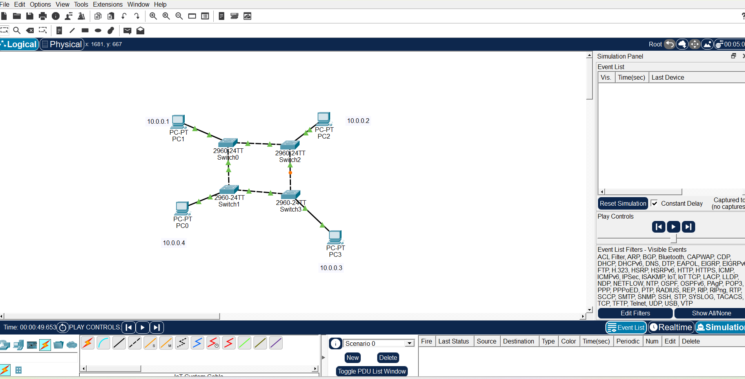

4. Procedure
- Add multiple PCs
- Connect each device to all others
- Assign IP addresses
- Test connectivity

5. Result
Mesh topology was successfully created and verified.

(Networking & Devices)
Parameter | Details
Network Type | Metropolitan Area Network (MAN)
Connecting Devices | Routers, switches, multiple links
Explanation | Mesh topology is used in MAN for high reliability and redundancy, ensuring communication even if one link fails.

EXPERIMENT 2(d): Tree Topology

1. Aim
To design and implement a Tree Topology using Cisco Packet Tracer.

2. Theory
Tree topology is a hierarchical structure that combines multiple star networks in parent-child form.

3. Network Diagram
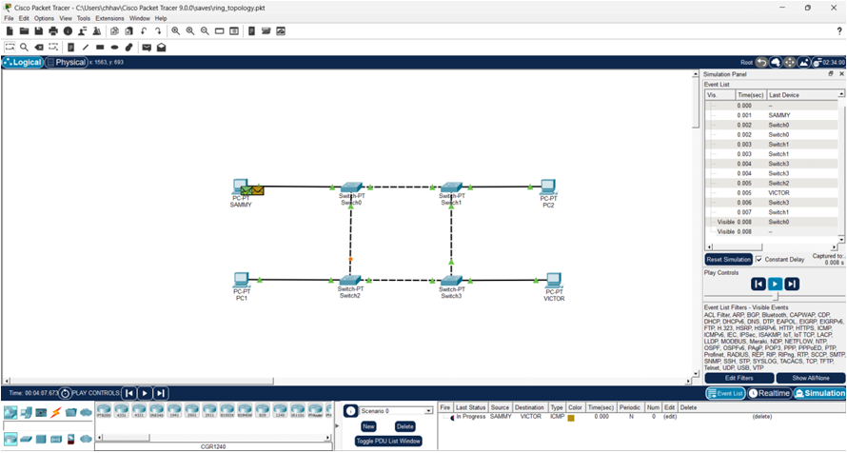

4. Procedure
- Add a root switch
- Connect child switches
- Connect PCs to switches
- Assign IP addresses
- Test connectivity

5. Result
Tree topology was successfully implemented and tested.

(Networking & Devices)
Parameter | Details
Network Type | Campus Area Network (CAN)
Connecting Devices | Core switch, access switches, PCs
Explanation | Tree topology is used in large campus networks where hierarchical design allows better scalability and management.

EXPERIMENT 3
CONSTRUCTING AND UNDERSTANDING THE PURPOSE OF A LAN

EXPERIMENT 3(a): LAN using Switch

1. Aim
To design and implement a Local Area Network (LAN) using a switch in Cisco Packet Tracer.

2. Theory
A switch is an intelligent networking device that connects devices in a LAN and works on the Data Link Layer (Layer 2). It sends data only to the intended device using MAC addresses.

3. Network Diagram
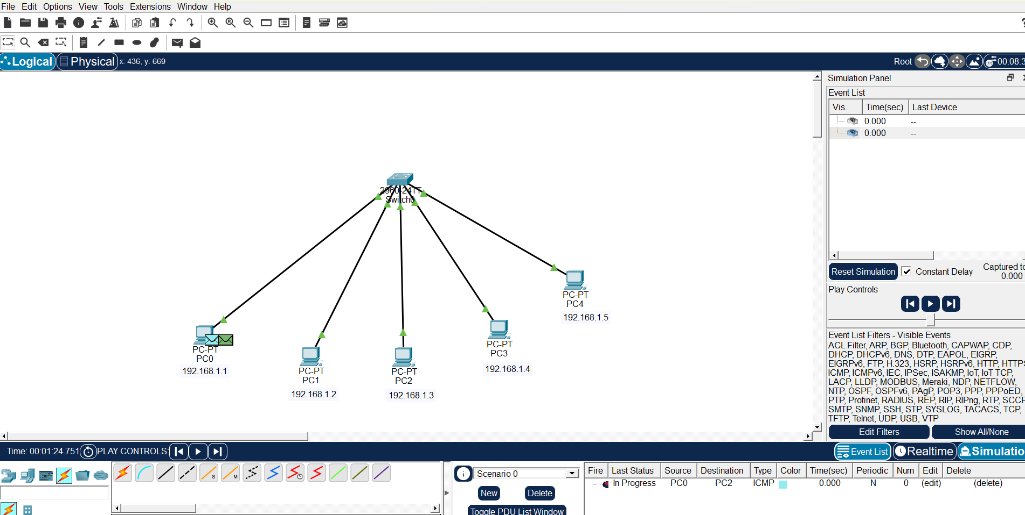

4. Procedure
- Place one switch in the workspace
- Add multiple PCs
- Connect PCs to switch using Copper Straight Through Cable
- Assign IP addresses
- Test connectivity using ping

5. Result
LAN using switch was successfully implemented with efficient communication between devices.

6. Advantages
- Faster communication
- No unnecessary data transmission
- Better security

7. Disadvantages
- Costlier than hub
- Requires configuration

(Networking & Devices)
Parameter | Details
Network Type | Local Area Network (LAN)
Connecting Devices | Switch, PCs, Ethernet cables
Explanation | Switch-based LAN improves performance by sending data only to the destination device, reducing traffic and collisions.
EXPERIMENT 3(b): LAN using Hub

1. Aim
To design and implement a Local Area Network (LAN) using a hub in Cisco Packet Tracer.

2. Theory
A hub is a basic networking device that connects multiple computers in a LAN. It works on the Physical Layer (Layer 1) and broadcasts data to all connected devices.

3. Network Diagram
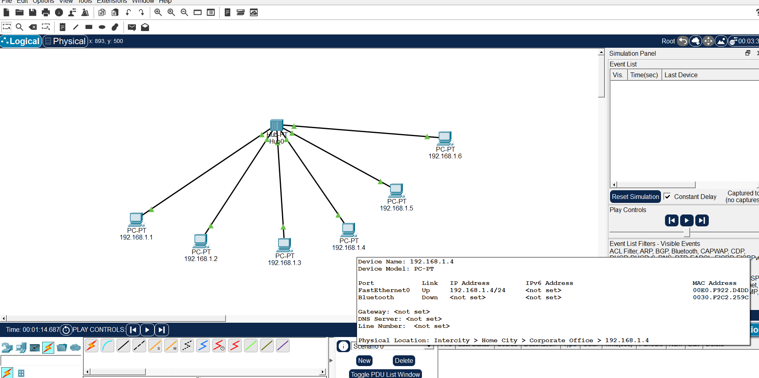

4. Procedure
- Place one hub in the workspace
- Add multiple PCs (3–5)
- Connect all PCs to hub using Copper Straight Through Cable
- Assign IP addresses manually
- Test connectivity using ping

5. Result
LAN using hub was successfully created. Communication was established, but data was broadcast to all devices.

6. Advantages
- Simple and low cost
- Easy to install

7. Disadvantages
- Data broadcast to all devices (low security)
- Network congestion
- No traffic control

(Networking & Devices)
Parameter | Details
Network Type | Local Area Network (LAN)
Connecting Devices | Hub, PCs, Ethernet cables
Explanation | Hub-based LAN is used for basic networking where all devices share the same bandwidth and receive all transmitted data.

EXPERIMENT 4
IMPLEMENTATION OF A CAMPUS AREA NETWORK (CAN): DESIGN AND IP SETTINGS

1. Aim
To design and implement a Campus Area Network (CAN) and perform proper IP address assignment using Cisco Packet Tracer.

2. Objectives
- To understand the concept of Campus Area Network
- To design a network connecting multiple departments
- To assign IP addresses systematically
- To test connectivity across the network

3. Theory
A Campus Area Network (CAN) is a network that connects multiple Local Area Networks (LANs) within a limited geographical area such as a college, university, or organization.
👉 It is larger than LAN but smaller than MAN
👉 Used for interconnecting departments (Admin, Labs, Library, etc.)
🔹 Key Features:
- High-speed connectivity
- Centralized management
- Scalable design

4. Network Design
👉 Typical design includes:
- Multiple switches (for departments)
- One central/core switch or router
- End devices (PCs) in each department

5. Network Diagram
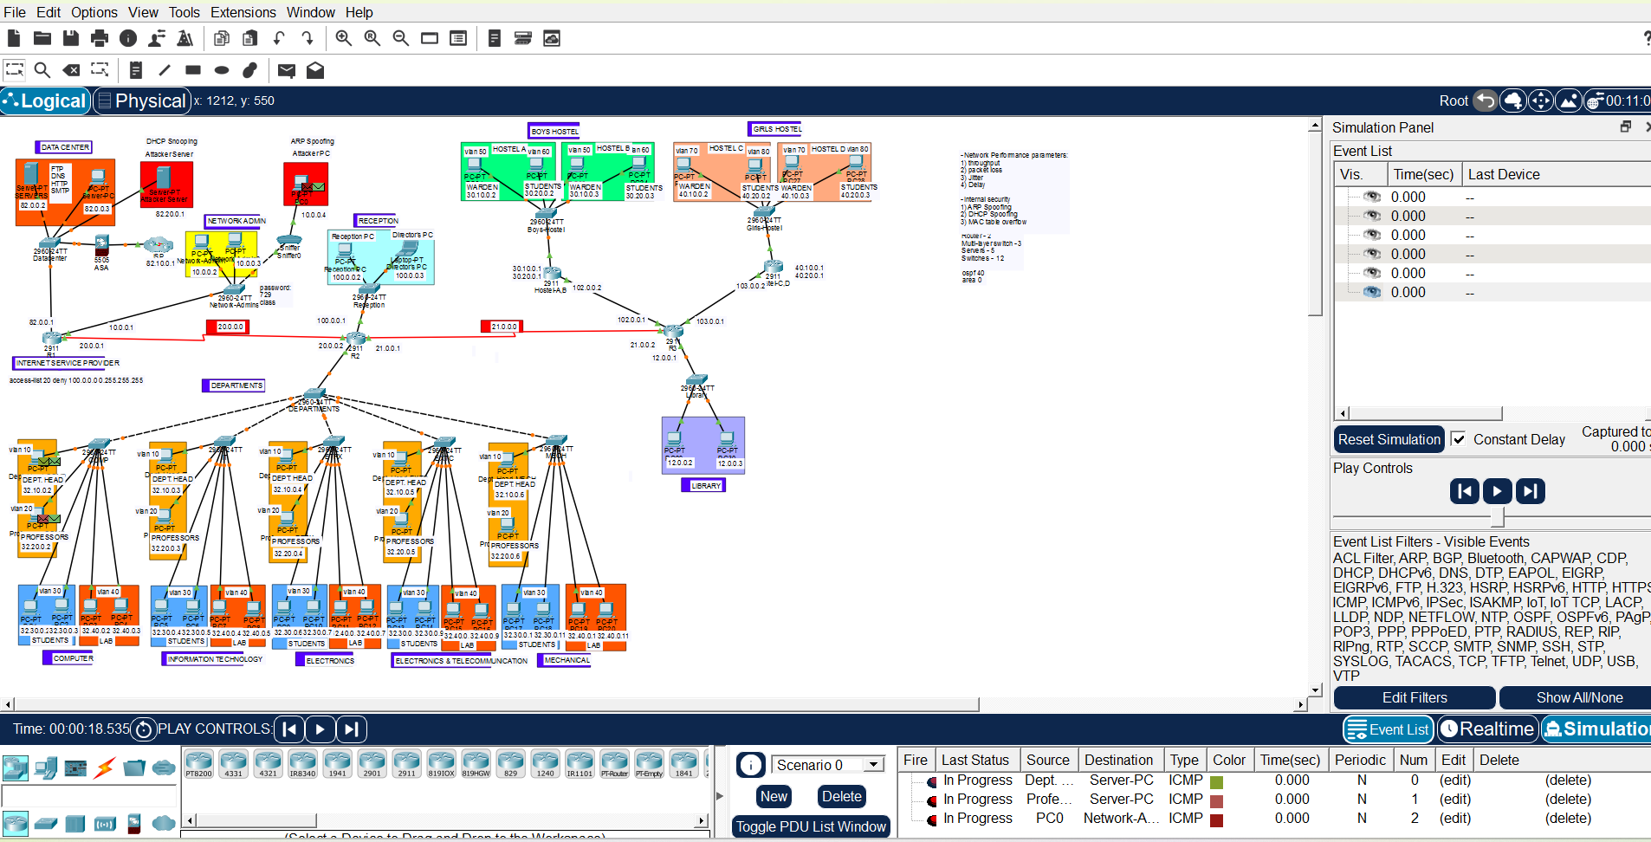

6. IP Addressing Scheme
Example:
Department | Device | IP Address | Subnet Mask
Lab | PC1 | 192.168.1.2 | 255.255.255.0
Lab | PC2 | 192.168.1.3 | 255.255.255.0
Office | PC1 | 192.168.2.2 | 255.255.255.0
Library | PC1 | 192.168.3.2 | 255.255.255.0
👉 Each department uses a different network (subnet)

7. Procedure
Step 1: Design Network
- Add switches for each department
- Add PCs in each department
- Connect switches to central switch/router

Step 2: Connect Devices
- Use Copper Straight Through Cable
- Ensure proper connections

Step 3: Assign IP Addresses
- Assign IPs based on department
- Example:
  - Lab → 192.168.1.0/24
  - Office → 192.168.2.0/24
  - Library → 192.168.3.0/24

Step 4: Test Connectivity
- Use Command Prompt
- Run:
ping 192.168.x.x
👉 Verify communication within and across departments

8. Result
The Campus Area Network was successfully designed and implemented. IP addresses were assigned properly, and communication between devices was verified.

9. Advantages
- Efficient resource sharing
- Centralized control
- Scalable network

10. Disadvantages
- Complex setup
- Requires proper planning
- Higher cost than LAN

🔻 Footnote (Networking & Devices)
Parameter | Details
Network Type | Campus Area Network (CAN)
Connecting Devices | Core switch/router, access switches, PCs, Ethernet cables
Explanation | CAN connects multiple LANs within a campus using hierarchical design, allowing efficient communication and centralized management.

EXPERIMENT 5
Implementing over the IP Layer

A. Understanding the Concept of Subnetting

1. Aim
To understand and implement subnetting by dividing a network into smaller sub-networks.

2. Objective
- To understand IP addressing and subnetting
- To divide a network into multiple subnets
- To calculate subnet mask, network ID, and broadcast ID

3. Theory
Subnetting is the process of dividing a large network into smaller networks (subnets) to improve performance and security.
👉 It helps in:
- Efficient IP utilization
- Reducing network congestion
- Better management

4. Example of Subnetting
Given Network: 192.168.1.0/24
Divided into 4 subnets
Subnet | Network Address | Usable IP Range | Broadcast Address
1 | 192.168.1.0 | 192.168.1.1 – 192.168.1.30 | 192.168.1.31
2 | 192.168.1.32 | 192.168.1.33 – 192.168.1.62 | 192.168.1.63
3 | 192.168.1.64 | 192.168.1.65 – 192.168.1.94 | 192.168.1.95
4 | 192.168.1.96 | 192.168.1.97 – 192.168.1.126 | 192.168.1.127
Subnet Mask: 255.255.255.224 (/27)

5. Network Diagram (Subnetting)
👉 INSERT IMAGE HERE (Subnetting Topology)
✔ Show:
- Router
- Multiple subnets
- PCs in each subnet

6. Procedure
- Take network 192.168.1.0/24
- Divide into 4 subnets
- Assign IP addresses to devices
- Configure network in Packet Tracer
- Verify connectivity

7. Result
Subnetting was successfully implemented, and the network was divided into smaller subnets.
B. Implementing Traceroute and Ping Command in CPT

1. Aim
To implement and analyze Ping and Traceroute commands in Cisco Packet Tracer.

2. Objective
- To test connectivity between devices
- To trace path of packets in network

3. Theory
🔹 Ping Command
- Used to check connectivity between devices
- Uses ICMP protocol
👉 Example:
ping 192.168.1.2

🔹 Traceroute Command
- Shows the path taken by data packets
- Helps in troubleshooting
👉 Example:
tracert 192.168.1.2

4. Network Diagram
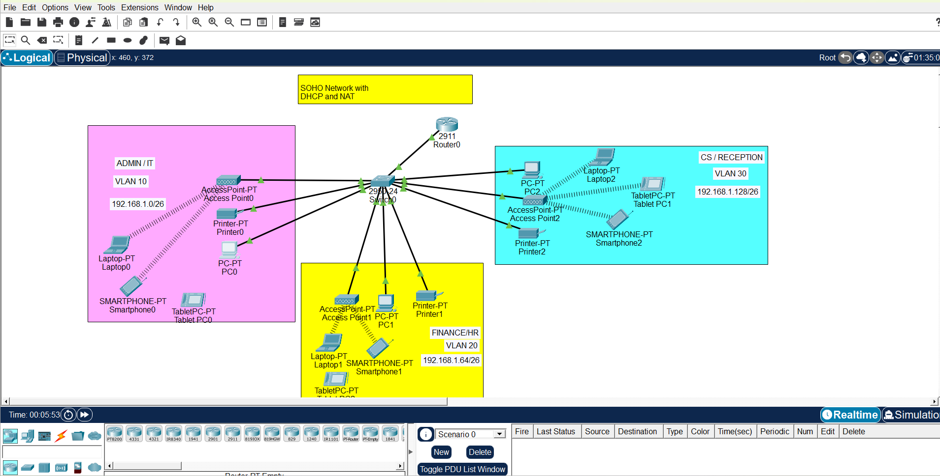

5. Procedure
Step 1: Create Network
- Add PCs and routers
- Connect devices properly

Step 2: Assign IP Addresses
- Configure IPs on all devices

Step 3: Test Ping
- Open Command Prompt
- Run:
ping 192.168.1.133
👉 Check replies

Step 4: Run Traceroute
- In Command Prompt:
tracert 192.168.1.133
👉 Observe path

6. Output Screenshots
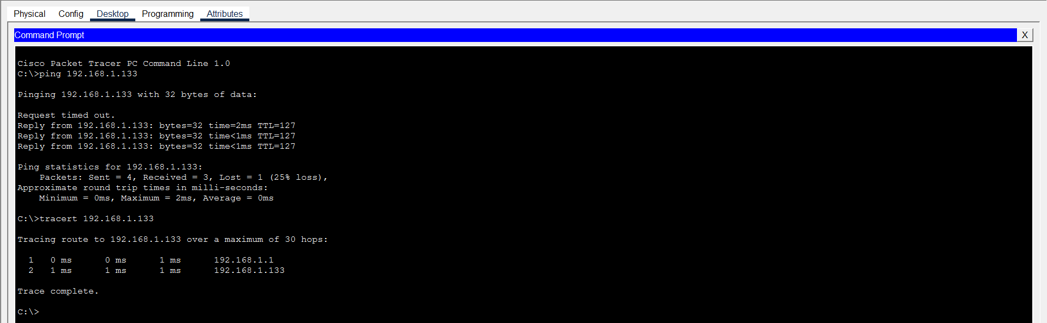

7. Result
Ping command successfully verified connectivity, and Traceroute displayed the path followed by packets.

(Networking & Devices)
Parameter | Details
Network Type | Local Area Network (LAN) / Campus Area Network (CAN)
Connecting Devices | Routers, switches, PCs, Ethernet cables
Explanation | Subnetting improves network efficiency, while Ping and Traceroute help in testing and troubleshooting connectivity across networks.

EXPERIMENT 6
Wireless Home Network – Setting up a Router

1. Aim
To design and configure a Wireless Home Network using a router in Cisco Packet Tracer.

2. Objectives
- To understand wireless networking concepts
- To configure a wireless router
- To connect wired and wireless devices
- To test network connectivity

3. Theory
A Wireless Home Network allows multiple devices (laptops, smartphones, PCs) to connect using Wi-Fi through a wireless router.
👉 The router performs:
- DHCP (automatic IP assignment)
- Routing (internet access)
- Wireless communication (Wi-Fi)
🔹 Key Components:
- Wireless Router
- End Devices (PC, Laptop, Mobile)
- Ethernet cables

4. Network Diagram
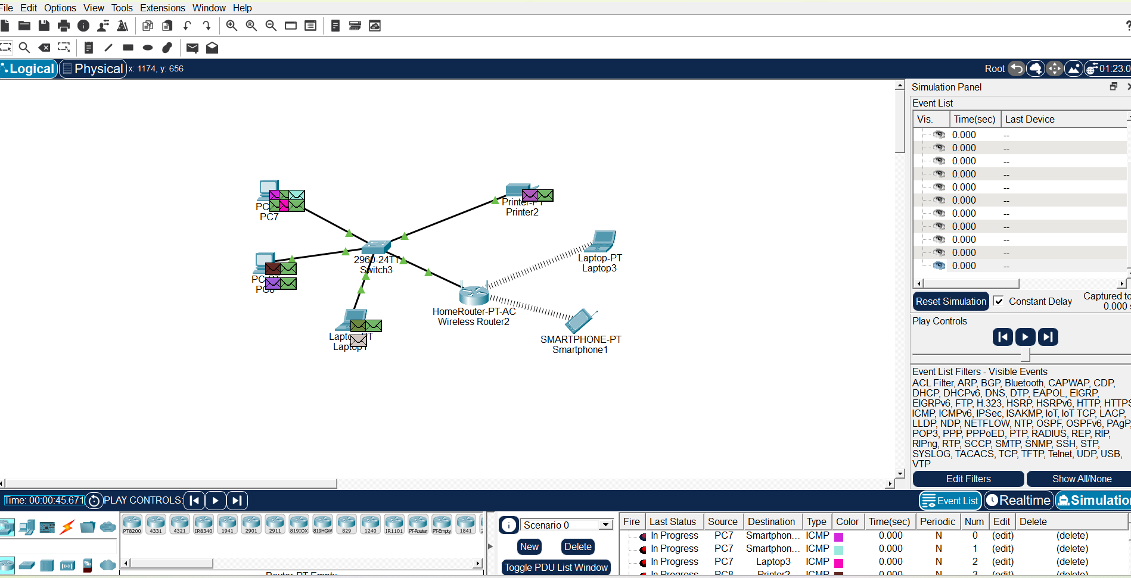

5. Procedure
Step 1: Add Devices
- Place a Wireless Router (WRT300N)
- Add PCs and Laptops

Step 2: Connect Wired Devices
- Connect PC to router using Copper Straight Through Cable

Step 3: Configure Router
👉 Click Router → GUI Tab
- Set SSID (Wi-Fi Name) → e.g., Home_Network
- Set Password → WPA2 security
- Enable DHCP

Step 4: Connect Wireless Device
👉 Laptop:
- Desktop → PC Wireless
- Select SSID
- Enter password

Step 5: IP Configuration
- Ensure devices receive IP automatically via DHCP

Step 6: Test Connectivity
ping 192.168.0.1
👉 Ping router or other device

6. Result
Wireless Home Network was successfully configured. Devices were able to connect and communicate through the router.

7. Advantages
- No cables required for wireless devices
- Easy to install
- Flexible and mobile

8. Disadvantages
- Security risks
- Signal interference
- Limited range

(Networking & Devices)
Parameter | Details
Network Type | Local Area Network (LAN)
Connecting Devices | Wireless router, PCs, laptops, Wi-Fi
Explanation | Wireless networks allow devices to connect without cables, and routers manage communication using DHCP and wireless signals.

EXPERIMENT 7
CAPSTONE PROJECT: SOHO Network with DHCP and NAT

1. Aim
To design and implement a Small Office/Home Office (SOHO) Network using DHCP and NAT in Cisco Packet Tracer.

2. Objectives
- To design a complete SOHO network
- To configure DHCP for automatic IP assignment
- To implement NAT for internet access
- To verify communication within and outside the network

3. Theory
🔹 SOHO Network
A SOHO network is designed for small organizations or homes where multiple devices share internet and resources.

🔹 DHCP (Dynamic Host Configuration Protocol)
- Automatically assigns IP addresses
- Reduces manual configuration

🔹 NAT (Network Address Translation)
- Converts private IP → public IP
- Allows multiple devices to access internet using one IP
- Provides basic security

5. Network Diagram


6. IP Addressing Scheme
Device | IP Address | Subnet Mask
Router LAN | 192.168.1.1 | 255.255.255.0
Router WAN | Public IP (e.g., 200.0.0.1) | -
PCs | DHCP Assigned | 255.255.255.0

7. Configuration

🔹 Router Configuration (LAN)
interface fa0/0
ip address 192.168.1.1 255.255.255.0
no shutdown

🔹 DHCP Configuration
ip dhcp pool LAN
network 192.168.1.0 255.255.255.0
default-router 192.168.1.1

🔹 NAT Configuration
access-list 1 permit 192.168.1.0 0.0.0.255
ip nat inside source list 1 interface fa0/1 overload

🔹 Interface Configuration
interface fa0/0
ip nat inside
interface fa0/1
ip nat outside

8. Procedure
- Place router, switch, and PCs
- Connect all devices
- Configure router interfaces
- Enable DHCP
- Configure NAT
- Test connectivity

9. Testing
🔹 Internal Test
ping 192.168.1.x

🔹 Internet Test
ping 8.8.8.8

👉 Successful replies = Network working ✅

10. Result
The SOHO network was successfully implemented with DHCP and NAT. Devices received IP automatically and accessed external networks.

11. Advantages
- Automatic IP assignment
- Efficient internet sharing
- Secure internal network

12. Limitations
- Depends on router performance
- Limited scalability

(Networking & Devices)
Parameter | Details
Network Type | SOHO Network
Connecting Devices | Router, switch, PCs, ISP cloud
Explanation | SOHO networks use DHCP for automatic IP allocation and NAT to allow multiple devices to access the internet securely using a single public IP.

